kvitt KONGU ARTS AND SCIENCE COLLEGE, ERODE

DEPARMENT OF COMPUTER SCIENCE (UG)

IT NEWS WORLD

DATE: 24.06.2013

BIG DATA

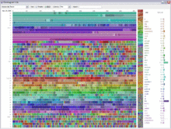 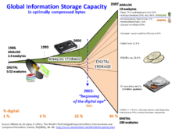

Big data is a buzzword, or catch-phrase, used to describe a massive volume of both structured and unstructured data that is so large that it's difficult to process using traditional database and software techniques. In most enterprise scenarios the data is too big or it moves too fast or it exceeds current processing capacity.

While the term may seem to reference the volume of data, that isn't always the case. The term big data, especially when used by vendors,  may refer to the technology (which includes tools and processes) that an organization requires to handle the large amounts of data and storage facilities. The term big data is believed to have originated with search companies who had to query very large distributed aggregations of loosely-structured data.

An example of big data might be pet bytes (1,024 terabytes) or Exabyte’s (1,024 pet bytes) of data consisting of billions to trillions of records of millions of people—all from different sources (e.g. Web, sales, customer contact center, social media, mobile data and so on). The data is typically loosely structured data that is often incomplete and inaccessible.When dealing with larger datasets, organizations face difficulties in being able to create, manipulate, and manage big data. Big data is particularly a problem in business analytics because standard tools and procedures are not designed to search and analyze massive datasets.

STAFF INCARGE SUBMITTED BY,

G. BALAJI

Ms K.G. SANTHIYA III B.Sc-( CS)-“A”

kvitt KONGU ARTS AND SCIENCE COLLEGE, ERODE

DEPARMENT OF COMPUTER SCIENCE (UG)

IT NEWS WORLD

DATE: 31.07.2013

**SCIENTIFIC CLOUD COMPUTING**

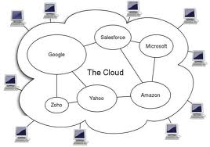

Scientific computing has already begun to change how science is done, enabling scientific breakthroughs through new kinds of experiments that would have been impossible only a decade ago. It is the key to solving "grand challenges" in many domains and providing breakthroughs in new knowledge, and it comes in many shapes and forms: high-performance computing (HPC), high-throughput computing (HTC), many-task computing (MTC), and data-intensive computing. Big data is generating datasets that are increasing exponentially in both complexity and volume, making their analysis, archival, and sharing one of the grand challenges of the 21st century. Not surprisingly, it becomes increasingly difficult to design and operate large scale systems capable of addressing these grand challenges

**Scientific Computing Using Spot Instances** :

AWS provides a comprehensive suite of tools to manage Scientific Computing workloads by utilizing services like: Amazon Elastic Compute Cloud (Amazon EC2) for scaling compute capacity up and down as needed, Amazon Simple Storage Service (Amazon S3) for storing data, and Amazon Elastic Map Reduce (Amazon EMR) to manage your Hadoop-based workflows. Amazon EC2 Spot Instances in particular is a pricing model targeted for batch processing use cases, providing your customers with the flexibility of ad-hoc provisioning while receiving significant price savings over other pricing models

STAFF INCARGE SUBMITTED BY,

C. RAJA

K.G. SANTHIYA III B.Sc ( CS)-“B”

kvitt KONGU ARTS AND SCIENCE COLLEGE, ERODE

DEPARMENT OF COMPUTER SCIENCE (UG)

IT NEWS WORLD

DATE: 13.08.2013

3D DOODLER:

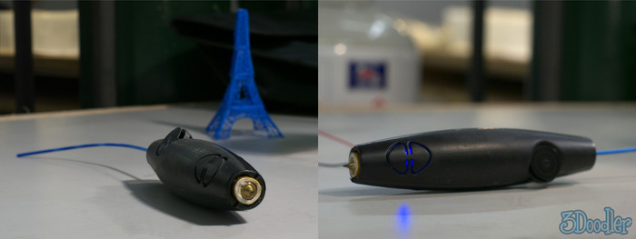

The **3Doodler** is a 3D printing pen developed by Peter Dilworth and Maxwell Bogue of WobbleWorks LLC. 3Doodler began funding in February 2013 on the crowd funding platformKickstarter. It utilizes plastic thread made of either acrylonitrile butadiene styrene ("ABS") or polylactic acid ("PLA") that is melted and then cooled through a patented process while moving through the pen, which can then be used to make 3D objects by hand. The 3Doodler has been described as a glue gun for 3D printing because of how the plastic is extruded from the tip, with one foot of the plastic thread equaling "about 11 feet of moldable material"

**What can I make with 3Doodler?**

There are many ways 3Doodler can be used. 3Doodles can be created as flat forms and peeled off a piece of paper, as freestyle 3D objects, or in separate parts, ready to be joined together using the 3Doodler. The creative opportunities are endless, including:

Basic 3D shapes and 3D models. Jewellery, pendants and hanging ornaments. Decorative art and fridge magnets. Personalization of everyday objects (iPhone cases, laptops, pens, etc.). A mini Eiffel Tower or a soccer pitch for your Lego men

STAFF INCARGE SUBMITTED BY,

S. MANI BHARATHI

K.G. SANTHIYA II B.Sc ( CS)- “A”

kvitt KONGU ARTS AND SCIENCE COLLEGE, ERODE

DEPARMENT OF COMPUTER SCIENCE (UG)

IT NEWS WORLD

DATE: 05.09.2013

**ANDROID ROBOTS:**

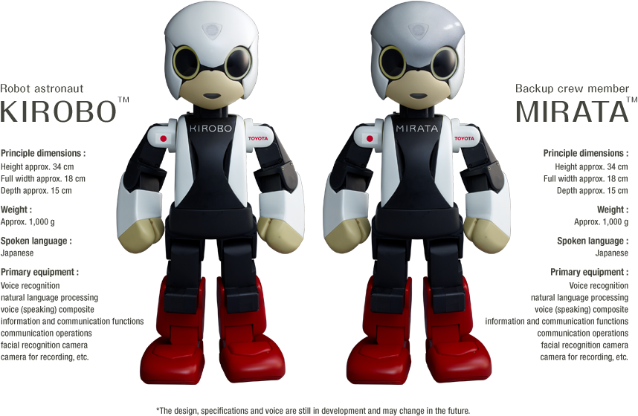

**Kirobo** is Japan's first robot astronaut, developed by Tomotaka Takahashi, to accompany Koichi Wakata, the first Japanese commander of the International Space Station. Kirobo arrived on the ISS with JAXA’s H-II Transfer Vehicle Kounotori 4, an unmanned resupply spacecraft launched August 4th 2013 from Japan's Tanegashima Space Center. A twin to Kirobo, named Mirata, was created with the same characteristics. Mirata will stay on Earth as a backup crew member. The word "kirobo" itself is a portmanteau of "kibō" (希望), which means "hope" in Japanese, and the word "robo" (ロボ), used as a generic short word for any robot

**Development:**

Kirobo was developed by a collaborative effort between Dentsu, the University of Tokyo's Research Center for Advanced Science and Technology, [Robo Garage](http://en.wikipedia.org/w/index.php?title=Robo_Garage&action=edit&redlink=1" \o "Robo Garage (page does not exist)), Toyota, and JAXA (Japan Aerospace Exploration Agency). The University of Tokyo and Robo Garage worked on the robot hardware and motion generation, Toyota created the voice recognitionfunction and Dentsu created the conversation content and managed the projectVoiceText of Hoya Service provided speech synthesis

STAFF INCARGE SUBMITTED BY,

J. MOHANA PRIYA

K.G. SANTHIYA I B.Sc CS (C)

kvitt KONGU ARTS AND SCIENCE COLLEGE, ERODE

DEPARMENT OF COMPUTER SCIENCE (UG)

IT NEWS WORLD

DATE: 01.10.2013

# ORACLE DATABASE 12C RUNS THE CLOUD

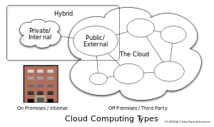

As organizations evolve their products, business models, and processes to keep pace with today’s dynamic global marketplace, Oracle is offering a powerful new database that’s optimized for cloud computing and Big Data, helping CIOs cut costs through consolidation and simplified management. Built expressly to help our customers extend their workloads from the traditional on-premise model into either public clouds or private clouds, Oracle Database 12c offers more than 500 new features to meet today’s information-intensive environments; including enhancements to help customers exploit emerging opportunities in Big Data and business analytics. Oracle Database 12c will help simplify the creation of private clouds, allow SaaS vendors to greatly enhance the level of functionality and security offered to customers, and serve as foundation for Oracle’s extensive set of public cloud services.

The innovations in Oracle Database 12c were developed with our customers’ cloud requirements very much in mind. The new multitenant architecture makes it easier for customers to consolidate their databases and securely manage many as one. Plus, it offers customers other cloud computing capabilities such as simplified provisioning, cloning, and resource prioritization without having to make changes to applications.

STAFF INCARGE SUBMITTED

K.G SANTHIYA P.S.GOWTHAM,

II B.Sc (CS)-“B”

kvitt KONGU ARTS AND SCIENCE COLLEGE, ERODE

DEPARMENT OF COMPUTER SCIENCE (UG)

IT NEWS WORLD

DATE: 06.12.2013

**UBUNTU TOUCH**

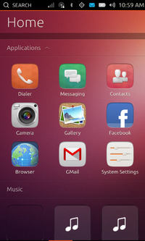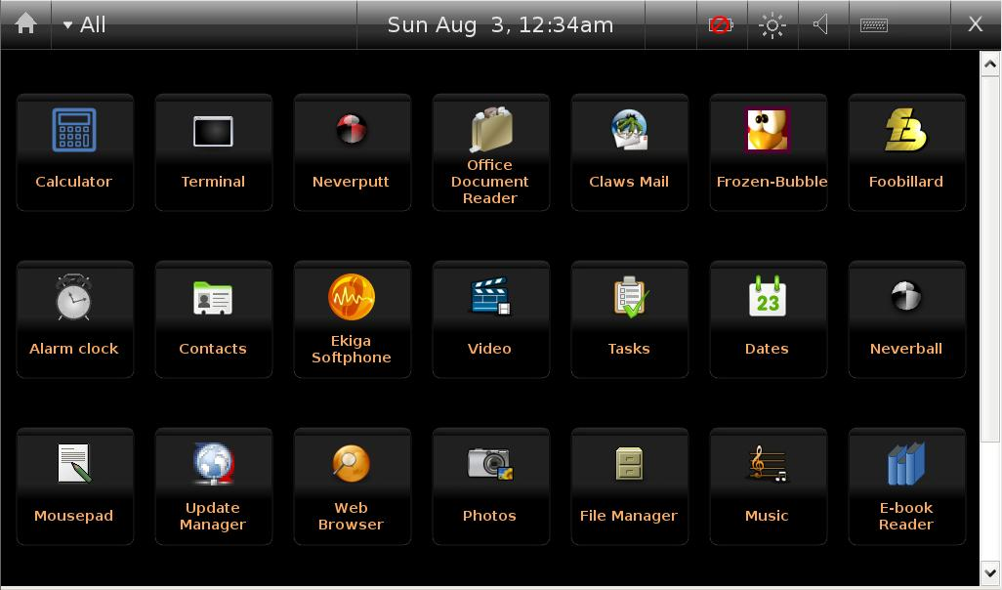

**Ubuntu Touch** is a mobile version of the Ubuntu operating system developed by Canonical UK Ltd. and Ubuntu Community It is designed primarily for touch screen mobile devices such as Smartphone and tablet computers.

Ubuntu Touch uses the Qt 5-based touch user interface and various software frameworks originally developed for Maemo and MeeGosuch as oFono as telephony stack.Ubuntu Touch utilizes the same core technologies as the Ubuntu Desktop, so applications designed for the latter platform run on the former and vice versa. Additionally, Ubuntu Desktop components come with the Ubuntu Touch system; allowing Ubuntu Touch devices to provide a full desktop experience when connected to an external monitor.[]](http://en.wikipedia.org/wiki/Ubuntu_Touch#cite_note-ecosys-8) Ubuntu Touch devices can be equipped with a full Ubuntu session and may change into a full desktop operating system when plugged into a docking station.

STAFF INCARGE SUBMITTED BY

K.G SANTHIYA K.K.NANDHINI

III B.Sc (CS)-“A”

kvitt KONGU ARTS AND SCIENCE COLLEGE, ERODE

DEPARMENT OF COMPUTER SCIENCE (UG)

IT NEWS WORLD

DATE: 24.01.2014

**BOOT CAMP**

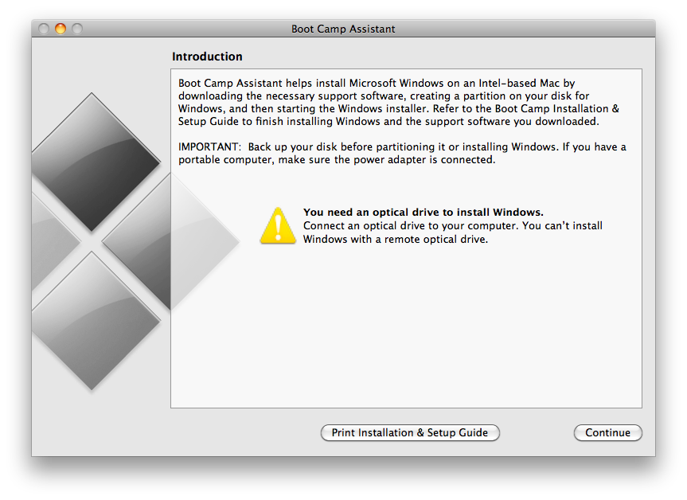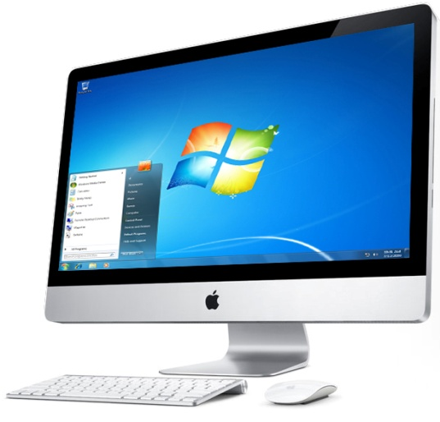

**Boot Camp** is a multi boot utility included with Apple Inc.'s OS X that assists users in installing Microsoft Windowsoperating systems on Intel-based Macintosh computers. The utility's **Boot Camp Assistant** guides users through non-destructive disk partitioning (including resizing of an existing HFS+ partition, if necessary) of their hard disk drive and installation of Windows device drivers. The utility also installs a Windows Control Panel applet for selecting the boot operating system.

Initially introduced as an unsupported beta for Mac OS X Tiger, the utility was first included with Mac OS X Leopard and has been included in subsequent versions of the operating system ever since. Previous versions of Boot Camp supported Windows XP, Windows Vista and Windows 7. Boot Camp 4.0 for Mac OS X Snow Leopard up to OS X Mountain Lion version 10.8.2 only supported Windows 7. However, with the release of Boot Camp 5.0 for OS X Mountain Lion version 10.8.3, only64-bit versions of Windows 7 and Windows 8 are officially supported. Users have also installed Linux using the utility, although Apple has not listed support for Linux operating systems.

STAFF INCARGE SUBMITTED BY

K.G SANTHIYA S.KUPPURAJ,

III B.Sc (CS)-“B”

kvitt KONGU ARTS AND SCIENCE COLLEGE, ERODE

DEPARMENT OF COMPUTER SCIENCE (UG)

IT NEWS WORLD

DATE: 17.02.2014

**CEO OF MICROSOFT:**

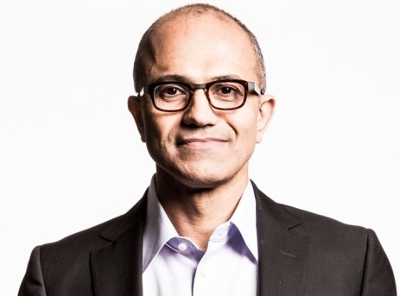

**Satya Narayana Nadella** (born 1967 in Hyderabad, India) is an Indian American business executive, engineer and the current chief executive officer of Microsoft. He was appointed CEO on 4 February 2014, succeeding Steve Ballmer. Previously, he was executive vice president of Microsoft's Cloud and Enterprise group, responsible for building and running the company's computing platforms, developer tools and cloud services.

**Career In Microsoft**

Nadella worked as the senior vice-president of research and development (R&D) for the Online Services Division and vice-president of the Microsoft Business Division. Later, he was made the president of Microsoft's $19 billion Server and Tools Business and led a transformation of the company's business and technology culture from client services to cloud infrastructure and services. He has been credited for helping bring Microsoft's database, Windows Server and developer tools to its Azure cloud. The revenue from Cloud Services grew to $20.3 billion in June 2013 from $16.6 billion when he took over in 2011.

Nadella's 2013 base salary is nearly $700,000, for a total compensation, with stock bonuses, of $7.6 million.Satya Nadella played a major role in Microsoft's transition to cloud computing.

STAFF INCARGE SUBMITTED BY,

K.G SANTHIYA T.NIVETHA

III B.Sc (CS)-“B”